Biology
Circulation
Gas Exchange

- Compare and contrast open and closed circulatory systems with regard to circulatory fluids, blood vessels, and pump (be sure to mention some advantages and disadvantages that these differences pose).

- What are the main differences between the circulatory systems and gas exchange tissues and structures of amphibians, reptiles and mammals? (be sure to mention the advantages each evolutionary development poses)

- Define the following terms:
  - Systole

  - Diastole

  - Stroke volume

  - Cardiac output

4. Label the ECG printout below with the electrical events (depolarization, re-polarization, etc. ) that take place within the tissue of the heart. Label the mechanical events (closing of AV valves, ventricular systole, diastole, closing of semilunar, etc.) that coincide with the electrical events. (or draw it on a sheet of paper, photo it, and then, attach it to your assignment)

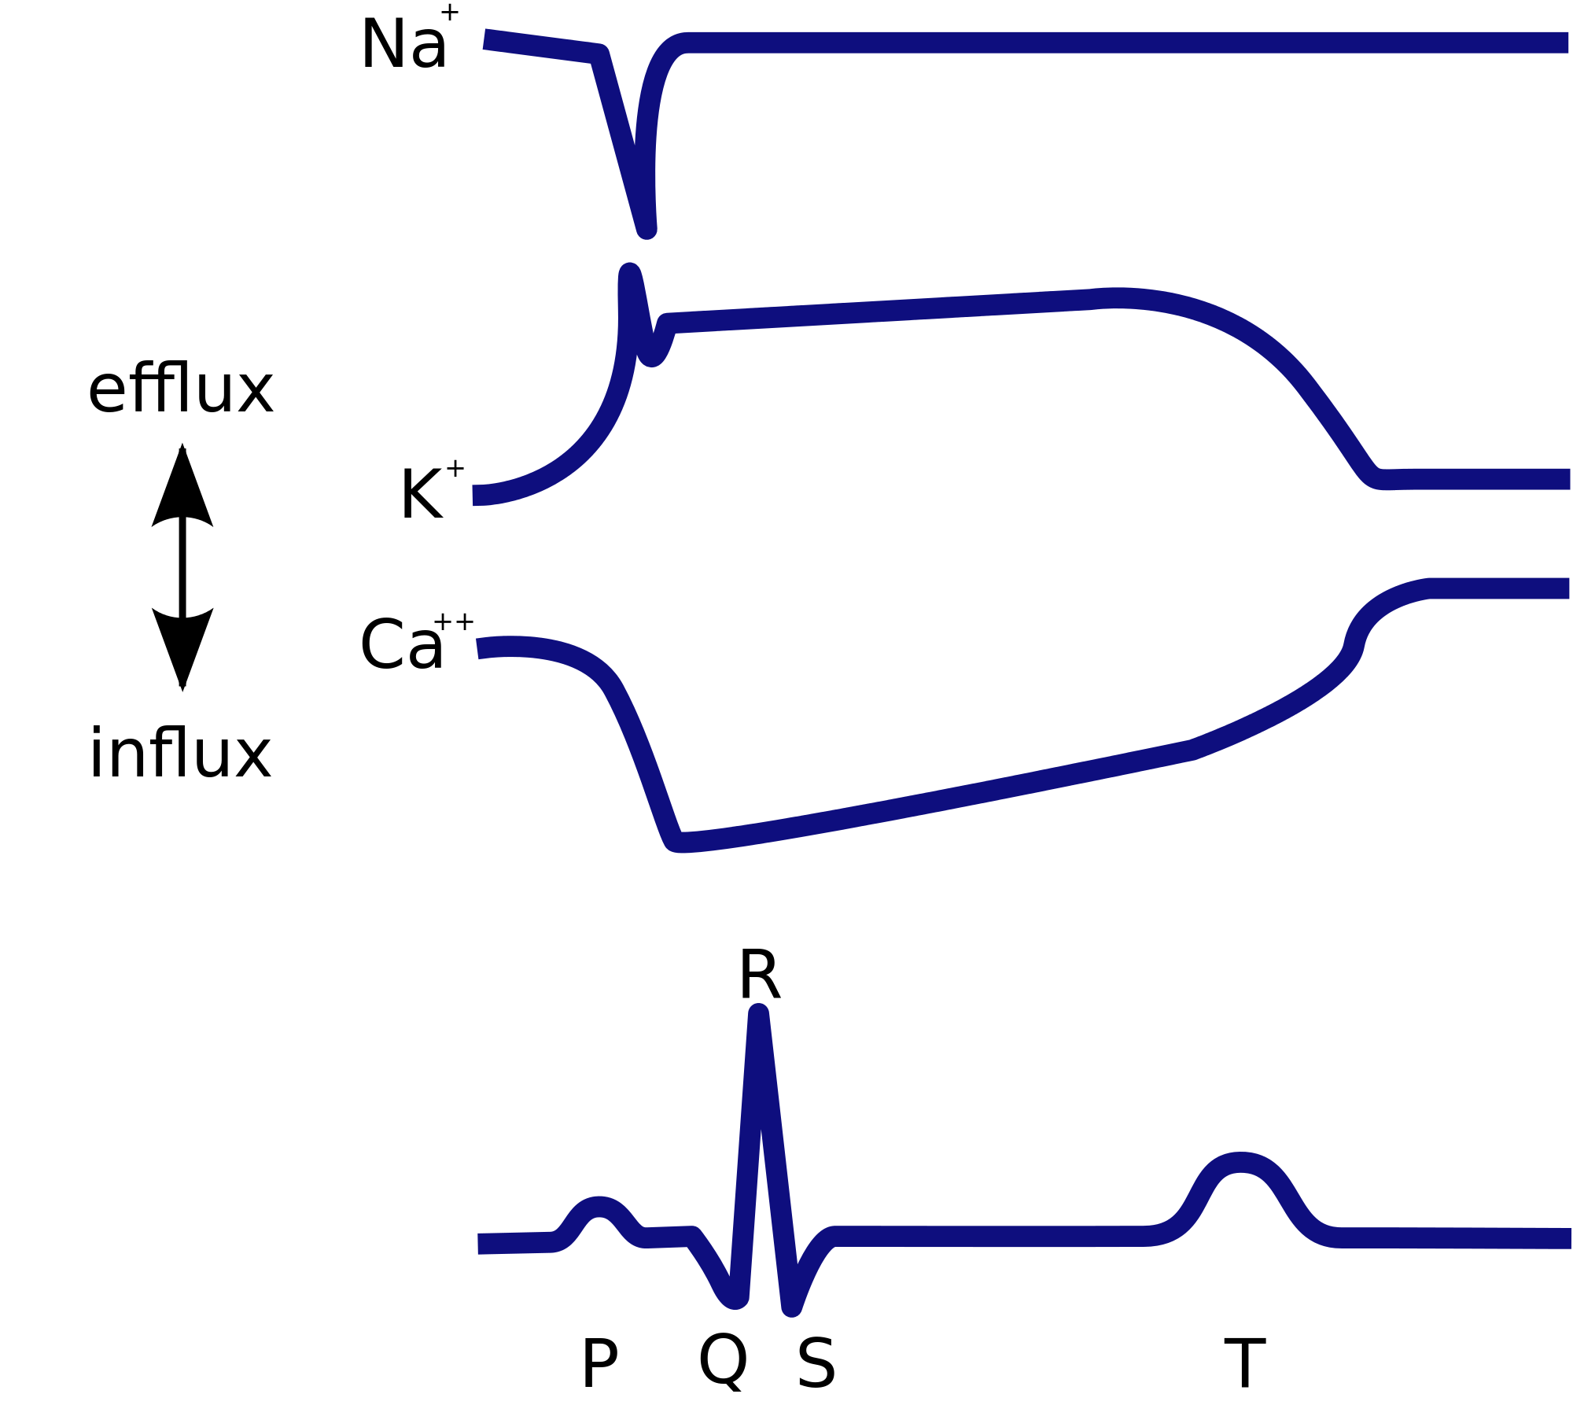

5. Describe the evolutionary stages of ventilation starting with the structure and abundance of gas exchange tissue in animals such as sea worms and sea stars, what does ventilation do and how did it begin, compare and contrast positive pressure vs negative pressure ventilation.

6. If hemoglobin performs best at a pH of 7.4 then explain how a pH of 7.4 or 7.6 affects the dissociation of O2 (feel free to draw a graph). Start by explaining how the pH of blood can change over time (hint* respiratory and metabolic).

